|  |  |
| --- | --- |
|  |  |
| **Uksw png 7 » PNG Image** | OBJECT RECOGNITION  **By. Christine Dewi, Ph.D.**  **Department of Information Technology,**  **Satya Wacana Christian University Salatiga, Indonesia** |
|  |  |

1. **Installs**
2. Anaconda

https://www.anaconda.com/products/distribution



1. Installation Process

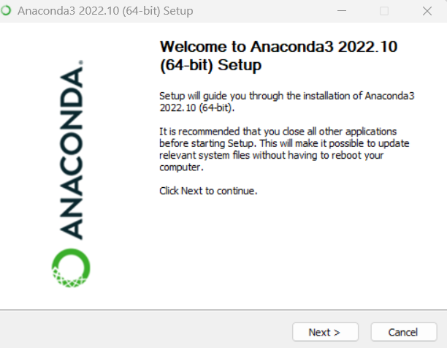

1. Installation finish, open your anaconda



1. Create new environment. Click tab environment >> create new environment >> name: Yolo >> Packages Python version 3.6.13 >> create

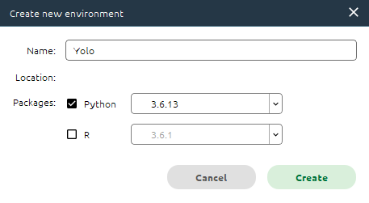

1. Click Yolo environment >> open terminal

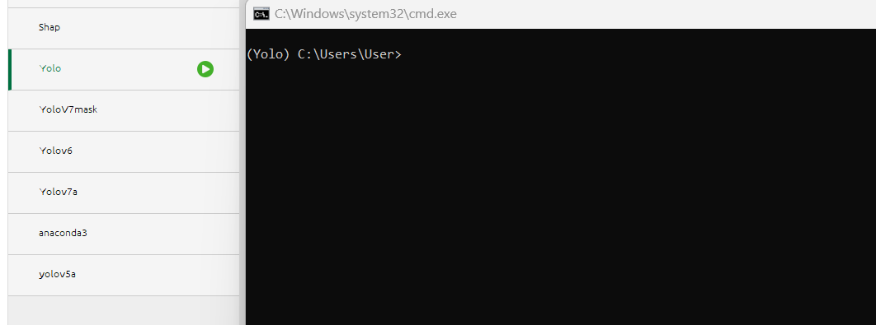

1. (Yolo) C:\Users\User>d:

(Yolo) D:\>cd D:\PROJECT\YoloObjectDetection

(Yolo) D:\PROJECT\YoloObjectDetection>

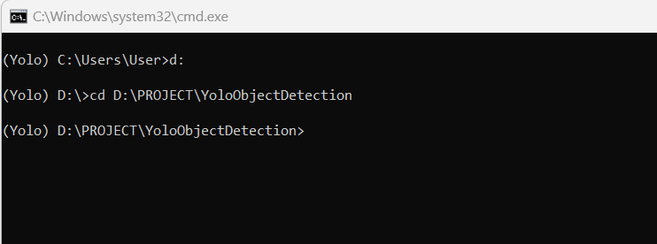

1. Install the necessary packages:

(Yolo) D:\PROJECT\YoloObjectDetection>conda install numpy

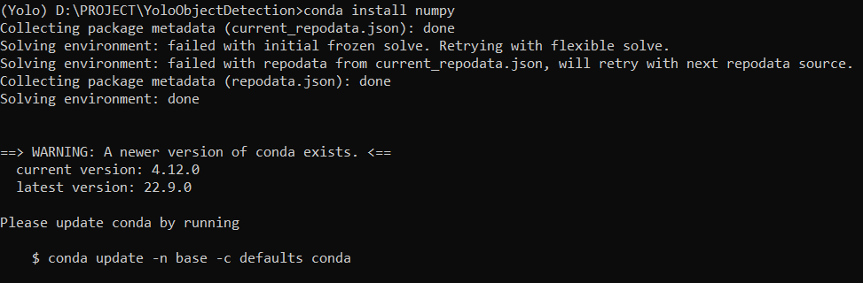

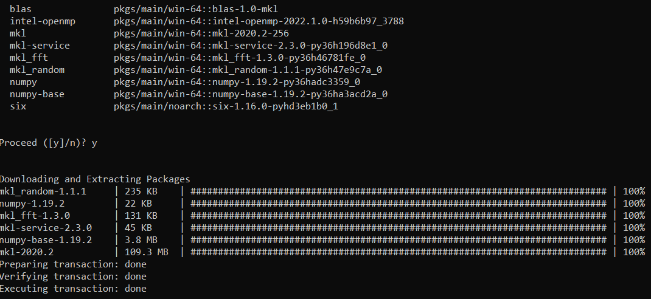

1. (Yolo) D:\PROJECT\YoloObjectDetection>conda install opencv

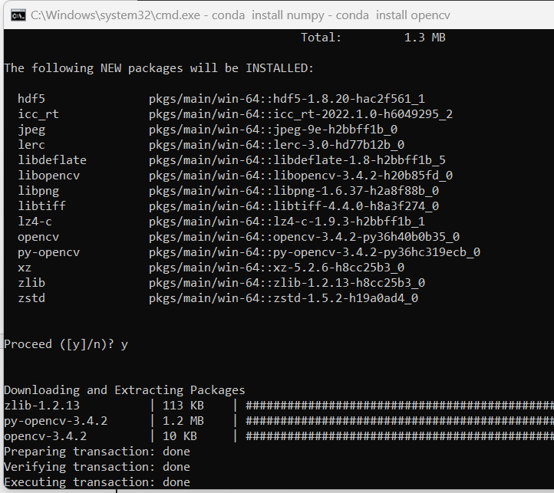

1. **Detect Image**

(Yolo) D:\PROJECT\YoloObjectDetection>python yolo.py --image images/a.jpg --yolo yolo-coco

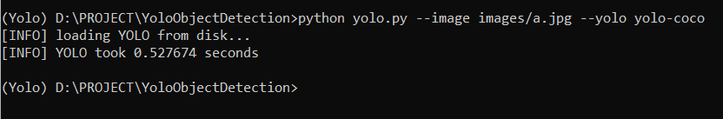

**Output:**

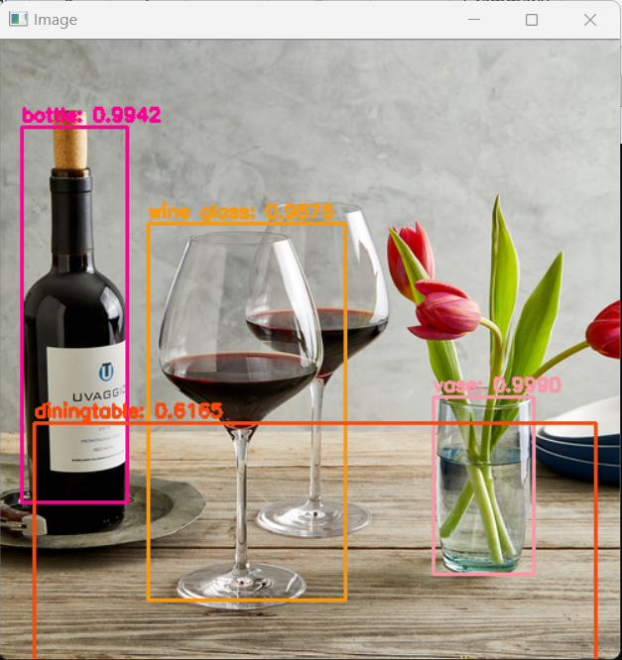

1. **Code yolo.py**

# USAGE

# python yolo.py --image images/baggage_claim.jpg --yolo yolo-coco

# import the necessary packages

import numpy as np

import argparse

import time

import cv2

import os

# construct the argument parse and parse the arguments

ap = argparse.ArgumentParser()

ap.add_argument("-i", "--image", required=True,

help="path to input image")

ap.add_argument("-y", "--yolo", required=True,

help="base path to YOLO directory")

ap.add_argument("-c", "--confidence", type=float, default=0.5,

help="minimum probability to filter weak detections")

ap.add_argument("-t", "--threshold", type=float, default=0.3,

help="threshold when applyong non-maxima suppression")

args = vars(ap.parse_args())

# load the COCO class labels our YOLO model was trained on

labelsPath = os.path.sep.join([args["yolo"], "coco.names"])

LABELS = open(labelsPath).read().strip().split("\n")

# initialize a list of colors to represent each possible class label

np.random.seed(42)

COLORS = np.random.randint(0, 255, size=(len(LABELS), 3),

dtype="uint8")

# derive the paths to the YOLO weights and model configuration

weightsPath = os.path.sep.join([args["yolo"], "yolov3.weights"])

configPath = os.path.sep.join([args["yolo"], "yolov3.cfg"])

# load our YOLO object detector trained on COCO dataset (80 classes)

print("[INFO] loading YOLO from disk...")

net = cv2.dnn.readNetFromDarknet(configPath, weightsPath)

# load our input image and grab its spatial dimensions

image = cv2.imread(args["image"])

(H, W) = image.shape[:2]

# determine only the *output* layer names that we need from YOLO

ln = net.getLayerNames()

ln = [ln[i[0] - 1] for i in net.getUnconnectedOutLayers()]

# construct a blob from the input image and then perform a forward

# pass of the YOLO object detector, giving us our bounding boxes and

# associated probabilities

blob = cv2.dnn.blobFromImage(image, 1 / 255.0, (416, 416),

swapRB=True, crop=False)

net.setInput(blob)

start = time.time()

layerOutputs = net.forward(ln)

end = time.time()

# show timing information on YOLO

print("[INFO] YOLO took {:.6f} seconds".format(end - start))

# initialize our lists of detected bounding boxes, confidences, and

# class IDs, respectively

boxes = []

confidences = []

classIDs = []

# loop over each of the layer outputs

for output in layerOutputs:

# loop over each of the detections

for detection in output:

# extract the class ID and confidence (i.e., probability) of

# the current object detection

scores = detection[5:]

classID = np.argmax(scores)

confidence = scores[classID]

# filter out weak predictions by ensuring the detected

# probability is greater than the minimum probability

if confidence > args["confidence"]:

# scale the bounding box coordinates back relative to the

# size of the image, keeping in mind that YOLO actually

# returns the center (x, y)-coordinates of the bounding

# box followed by the boxes' width and height

box = detection[0:4] * np.array([W, H, W, H])

(centerX, centerY, width, height) = box.astype("int")

# use the center (x, y)-coordinates to derive the top and

# and left corner of the bounding box

x = int(centerX - (width / 2))

y = int(centerY - (height / 2))

# update our list of bounding box coordinates, confidences,

# and class IDs

boxes.append([x, y, int(width), int(height)])

confidences.append(float(confidence))

classIDs.append(classID)

# apply non-maxima suppression to suppress weak, overlapping bounding

# boxes

idxs = cv2.dnn.NMSBoxes(boxes, confidences, args["confidence"],

args["threshold"])

# ensure at least one detection exists

if len(idxs) > 0:

# loop over the indexes we are keeping

for i in idxs.flatten():

# extract the bounding box coordinates

(x, y) = (boxes[i][0], boxes[i][1])

(w, h) = (boxes[i][2], boxes[i][3])

# draw a bounding box rectangle and label on the image

color = [int(c) for c in COLORS[classIDs[i]]]

cv2.rectangle(image, (x, y), (x + w, y + h), color, 2)

text = "{}: {:.4f}".format(LABELS[classIDs[i]], confidences[i])

cv2.putText(image, text, (x, y - 5), cv2.FONT_HERSHEY_SIMPLEX,

0.5, color, 2)

# show the output image

cv2.imshow("Image", image)

cv2.waitKey(0)

1. Try another image:

(Yolo) D:\PROJECT\YoloObjectDetection>python yolo.py --image images/living_room.jpg --yolo yolo-coco



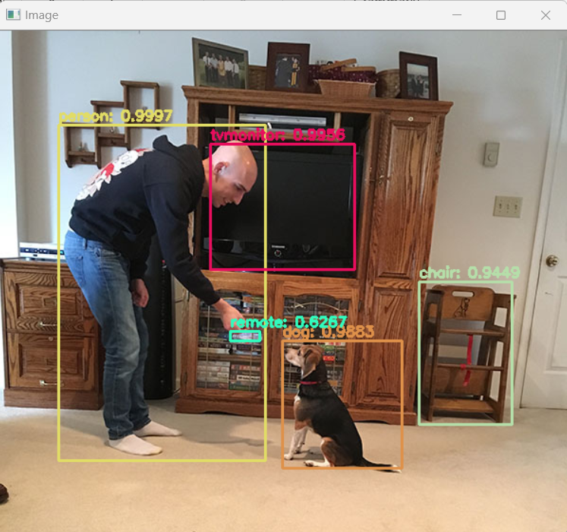

(Yolo) D:\PROJECT\YoloObjectDetection>python yolo.py --image images/baggage_claim.jpg --yolo yolo-coco



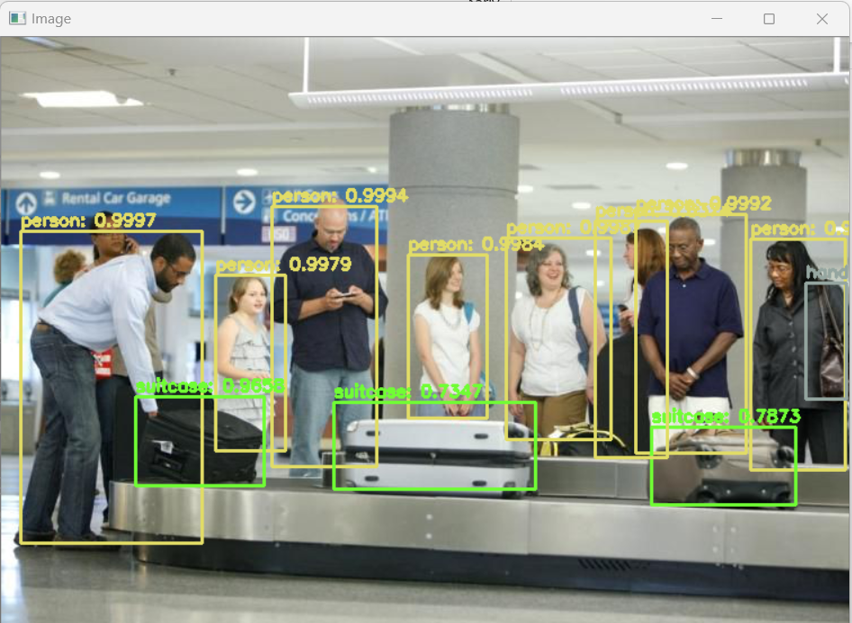

1. **Practice 1:**

Pleased find 10 images based on the list of coco.names and try to detect using yolo!

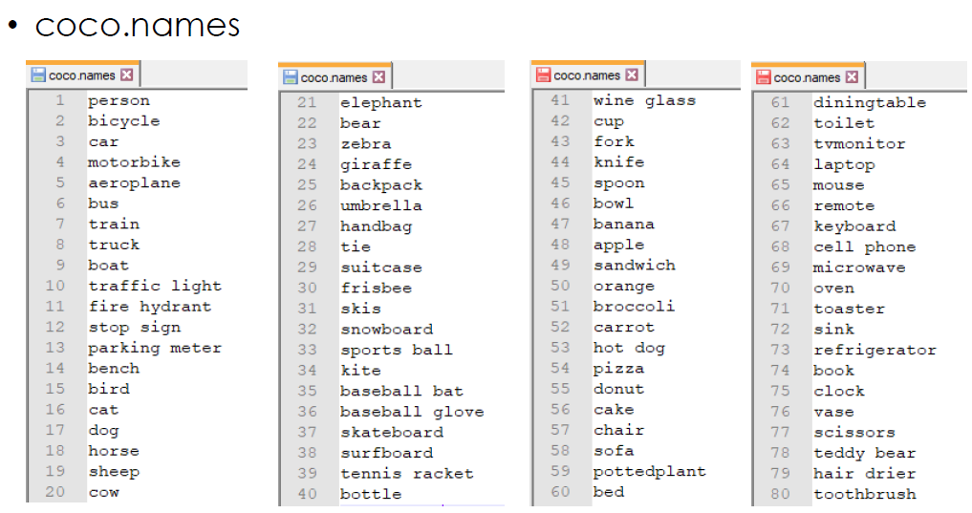

1. **Video Recognition**
2. **Install library**

(Yolo) D:\PROJECT\YoloObjectDetection>pip install imutils

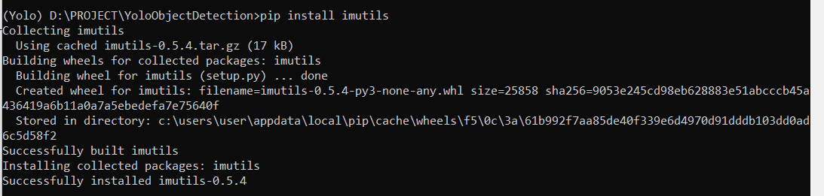

1. (Yolo) D:\PROJECT\YoloObjectDetection>python yolo_video.py --input videos/airport.mp4 --output output/airport_output.avi --yolo yolo-coco

(Yolo) D:\PROJECT\YoloObjectDetection>python yolo_video.py --input videos/airport.mp4 --output output/airport_output.avi --yolo yolo-coco

[INFO] loading YOLO from disk...

[INFO] 749 total frames in video

[INFO] single frame took 0.5667 seconds

[INFO] estimated total time to finish: 424.4713

[INFO] cleaning up...

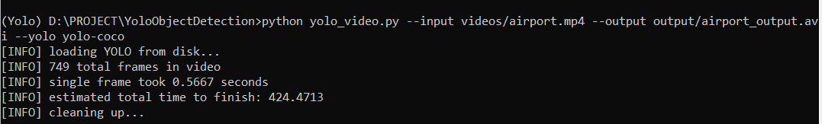

1. **Output**

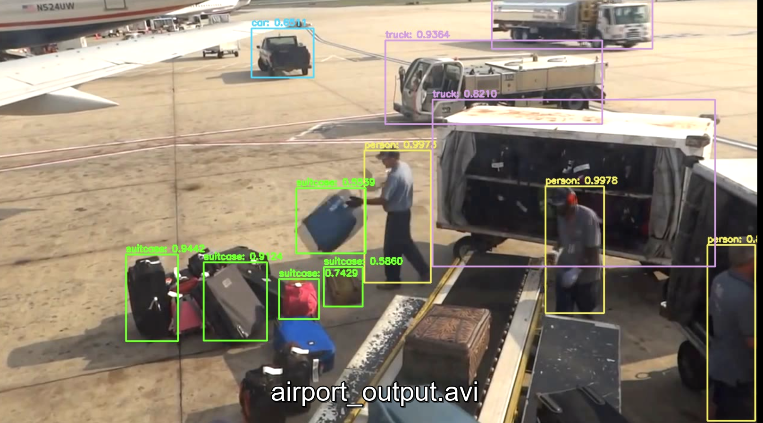

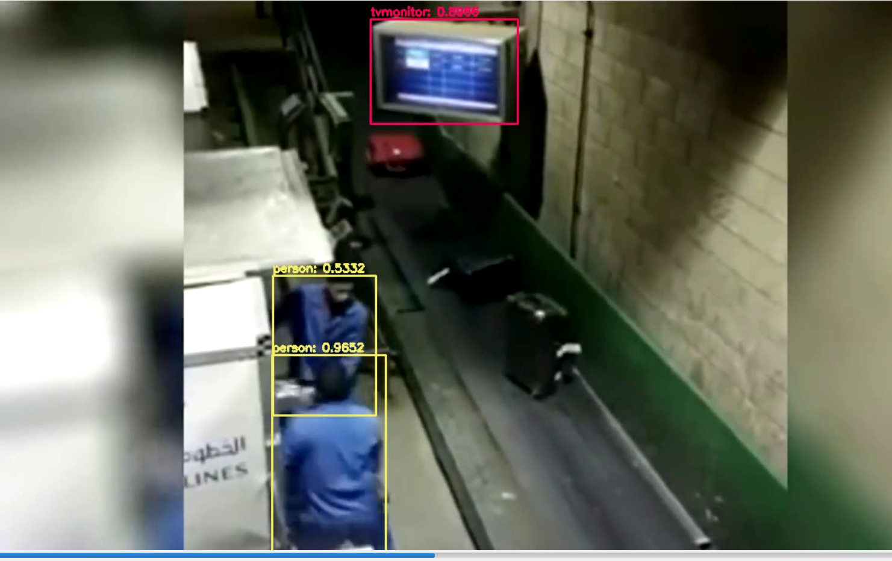

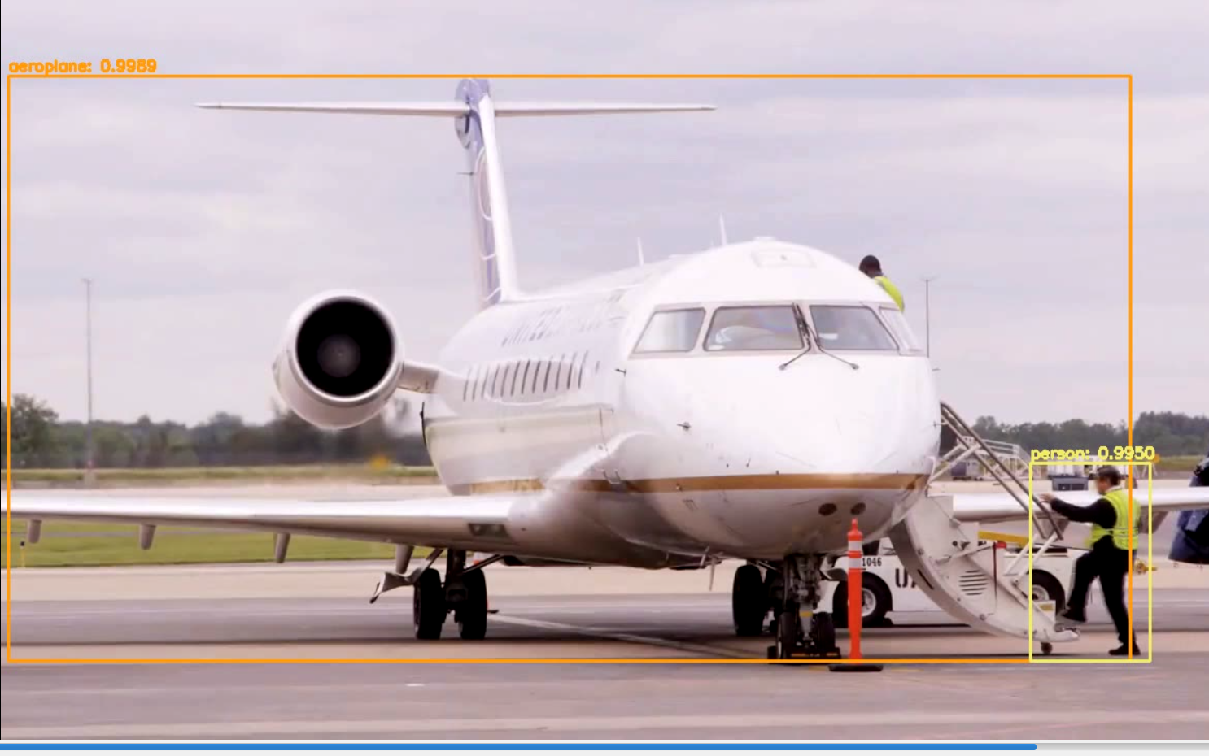

1. **yolo_video.py**

# USAGE

# python yolo_video.py --input videos/airport.mp4 --output output/airport_output.avi --yolo yolo-coco

# import the necessary packages

import numpy as np

import argparse

import imutils

import time

import cv2

import os

# construct the argument parse and parse the arguments

ap = argparse.ArgumentParser()

ap.add_argument("-i", "--input", required=True,

help="path to input video")

ap.add_argument("-o", "--output", required=True,

help="path to output video")

ap.add_argument("-y", "--yolo", required=True,

help="base path to YOLO directory")

ap.add_argument("-c", "--confidence", type=float, default=0.5,

help="minimum probability to filter weak detections")

ap.add_argument("-t", "--threshold", type=float, default=0.3,

help="threshold when applyong non-maxima suppression")

args = vars(ap.parse_args())

# load the COCO class labels our YOLO model was trained on

labelsPath = os.path.sep.join([args["yolo"], "coco.names"])

LABELS = open(labelsPath).read().strip().split("\n")

# initialize a list of colors to represent each possible class label

np.random.seed(42)

COLORS = np.random.randint(0, 255, size=(len(LABELS), 3),

dtype="uint8")

# derive the paths to the YOLO weights and model configuration

weightsPath = os.path.sep.join([args["yolo"], "yolov3.weights"])

configPath = os.path.sep.join([args["yolo"], "yolov3.cfg"])

# load our YOLO object detector trained on COCO dataset (80 classes)

# and determine only the *output* layer names that we need from YOLO

print("[INFO] loading YOLO from disk...")

net = cv2.dnn.readNetFromDarknet(configPath, weightsPath)

ln = net.getLayerNames()

ln = [ln[i[0] - 1] for i in net.getUnconnectedOutLayers()]

# initialize the video stream, pointer to output video file, and

# frame dimensions

vs = cv2.VideoCapture(args["input"])

writer = None

(W, H) = (None, None)

# try to determine the total number of frames in the video file

try:

prop = cv2.cv.CV_CAP_PROP_FRAME_COUNT if imutils.is_cv2() \

else cv2.CAP_PROP_FRAME_COUNT

total = int(vs.get(prop))

print("[INFO] {} total frames in video".format(total))

# an error occurred while trying to determine the total

# number of frames in the video file

except:

print("[INFO] could not determine # of frames in video")

print("[INFO] no approx. completion time can be provided")

total = -1

# loop over frames from the video file stream

while True:

# read the next frame from the file

(grabbed, frame) = vs.read()

# if the frame was not grabbed, then we have reached the end

# of the stream

if not grabbed:

break

# if the frame dimensions are empty, grab them

if W is None or H is None:

(H, W) = frame.shape[:2]

# construct a blob from the input frame and then perform a forward

# pass of the YOLO object detector, giving us our bounding boxes

# and associated probabilities

blob = cv2.dnn.blobFromImage(frame, 1 / 255.0, (416, 416),

swapRB=True, crop=False)

net.setInput(blob)

start = time.time()

layerOutputs = net.forward(ln)

end = time.time()

# initialize our lists of detected bounding boxes, confidences,

# and class IDs, respectively

boxes = []

confidences = []

classIDs = []

# loop over each of the layer outputs

for output in layerOutputs:

# loop over each of the detections

for detection in output:

# extract the class ID and confidence (i.e., probability)

# of the current object detection

scores = detection[5:]

classID = np.argmax(scores)

confidence = scores[classID]

# filter out weak predictions by ensuring the detected

# probability is greater than the minimum probability

if confidence > args["confidence"]:

# scale the bounding box coordinates back relative to

# the size of the image, keeping in mind that YOLO

# actually returns the center (x, y)-coordinates of

# the bounding box followed by the boxes' width and

# height

box = detection[0:4] * np.array([W, H, W, H])

(centerX, centerY, width, height) = box.astype("int")

# use the center (x, y)-coordinates to derive the top

# and and left corner of the bounding box

x = int(centerX - (width / 2))

y = int(centerY - (height / 2))

# update our list of bounding box coordinates,

# confidences, and class IDs

boxes.append([x, y, int(width), int(height)])

confidences.append(float(confidence))

classIDs.append(classID)

# apply non-maxima suppression to suppress weak, overlapping

# bounding boxes

idxs = cv2.dnn.NMSBoxes(boxes, confidences, args["confidence"],

args["threshold"])

# ensure at least one detection exists

if len(idxs) > 0:

# loop over the indexes we are keeping

for i in idxs.flatten():

# extract the bounding box coordinates

(x, y) = (boxes[i][0], boxes[i][1])

(w, h) = (boxes[i][2], boxes[i][3])

# draw a bounding box rectangle and label on the frame

color = [int(c) for c in COLORS[classIDs[i]]]

cv2.rectangle(frame, (x, y), (x + w, y + h), color, 2)

text = "{}: {:.4f}".format(LABELS[classIDs[i]],

confidences[i])

cv2.putText(frame, text, (x, y - 5),

cv2.FONT_HERSHEY_SIMPLEX, 0.5, color, 2)

# check if the video writer is None

if writer is None:

# initialize our video writer

fourcc = cv2.VideoWriter_fourcc(*"MJPG")

writer = cv2.VideoWriter(args["output"], fourcc, 30,

(frame.shape[1], frame.shape[0]), True)

# some information on processing single frame

if total > 0:

elap = (end - start)

print("[INFO] single frame took {:.4f} seconds".format(elap))

print("[INFO] estimated total time to finish: {:.4f}".format(

elap * total))

# write the output frame to disk

writer.write(frame)

# release the file pointers

print("[INFO] cleaning up...")

writer.release()

vs.release()

1. **Try another video:**

(Yolo) D:\PROJECT\YoloObjectDetection>python yolo_video.py --input videos/car_chase_01.mp4 --output output/car_chase_01_output.avi --yolo yolo-coco

(Yolo) D:\PROJECT\YoloObjectDetection>python yolo_video.py --input videos/car_chase_01.mp4 --output output/car_chase_01_output.avi --yolo yolo-coco

[INFO] loading YOLO from disk...

[INFO] 350 total frames in video

[INFO] single frame took 0.5411 seconds

[INFO] estimated total time to finish: 189.3978

[INFO] cleaning up...

**Output:**

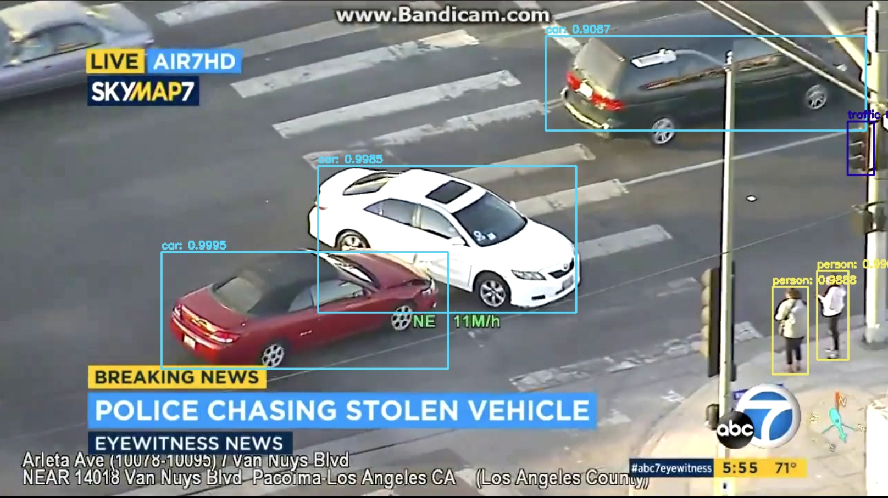

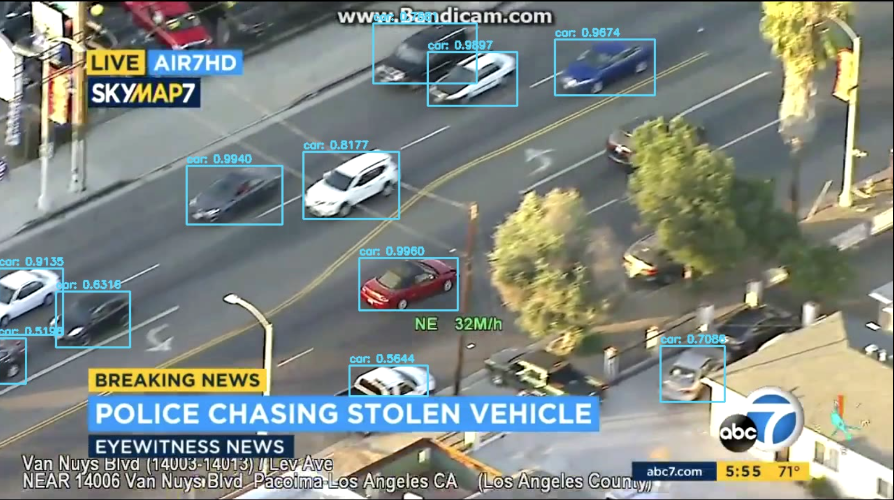

1. **Practice 2:**

Pleased find 2 short videos based on the list of coco.names and try to detect using yolo!

**Reference:**

https://pyimagesearch.com/2018/11/12/yolo-object-detection-with-opencv/